# Thermometer

## Analyse

*Taget fra* <https://www.ametherm.com/blog/thermistors/temperature-sensor-types>:

## **Temperature Sensor Types**

Temperature detection is the foundation for all advanced forms of temperature control and compensation. The temperature detection circuit itself monitors ambient temperature. It can then notify the system either of the actual temperature or, if the detection circuit is more intelligent, when a temperature control event occurs. When a specific high temperature threshold is exceeded, preventative action can be taken by the system to lower the temperature. An example of this is turning on a fan.

Similarly, a temperature detection circuit can serve as the core of a temperature compensation function. Consider a system such as liquid measuring equipment. Temperature, in this case, directly affects the volume measured. By taking temperature into account, the system can compensate for changing environment factors, enabling it to operate reliably and consistently. **There are four commonly used temperature sensor types:**

**1. Negative Temperature Coefficient (NTC) thermistor**

A thermistor is a [**thermally sensitive resistor**](https://www.ametherm.com/thermistor/what-is-a-thermistor/) that exhibits a large, predictable, and precise change in resistance correlated to variations in temperature. [**An NTC thermistor** provides a very high resistance at low temperatures.](https://www.ametherm.com/thermistor/what-is-an-ntc-thermistor) As temperature increases, the resistance drops quickly. Because an NTC thermistor experiences such a large change in resistance per **°**C, small changes in temperature are reflected very fast and with high accuracy (0.05 to 1.5 **°**C). Because of its exponential nature, the output of an NTC thermistor requires linearization. The effective operating range is -50 to 250 **°**C for [**glass encapsulated thermistors**](https://www.ametherm.com/thermistor/ntc-thermistors-glass-encapsulated) or 150**°**C for standard.

**2. Resistance Temperature Detector (RTD)**

An RTD, also known as a resistance thermometer, [**measures temperature by correlating the resistance of the RTD element with temperature**.](https://en.wikipedia.org/wiki/Resistance_thermometer) An RTD consists of a film or, for greater accuracy, a wire wrapped around a ceramic or glass core. The most accurate RTDs are made using platinum but lower-cost RTDs can be made from nickel or copper. However, nickle and copper are not as stable or repeatable. Platinum RTDs offer a fairly linear output that is highly accurate (0.1 to 1 **°**C) across -200 to 600 **°**C. While providing the greatest accuracy, RTDs also tend to be the most expensive of temperature sensors.

**3. Thermocouple**

This temperature sensor type consists of two wires of different metals connected at two points. The varying voltage between these two points reflects proportional changes in temperature. [**Thermocouples**](https://www.ametherm.com/blog/thermistors/temperature-sensors-thermistors-vs-thermocouples) are nonlinear, requiring conversion when used for temperature control and compensation, typically accomplished using a lookup table. **Accuracy is low**, from 0.5 °C to 5 **°**C.  However, they operate across the **widest temperature range**, from -200 °C to 1750 **°**C.

**4. Semiconductor-based sensors**

A semiconductor-based temperature sensor is placed on **integrated circuits** (ICs). These sensors are effectively two identical diodes with **temperature-sensitive voltage** vs current characteristics that can be used to monitor changes in temperature. They offer a linear response but have the lowest accuracy of the basic sensor types at 1 **°**C to 5 **°**C. They also have the slowest responsiveness (5 s to 60 s) across the narrowest temperature range (-70 **°**C to 150 **°**C).

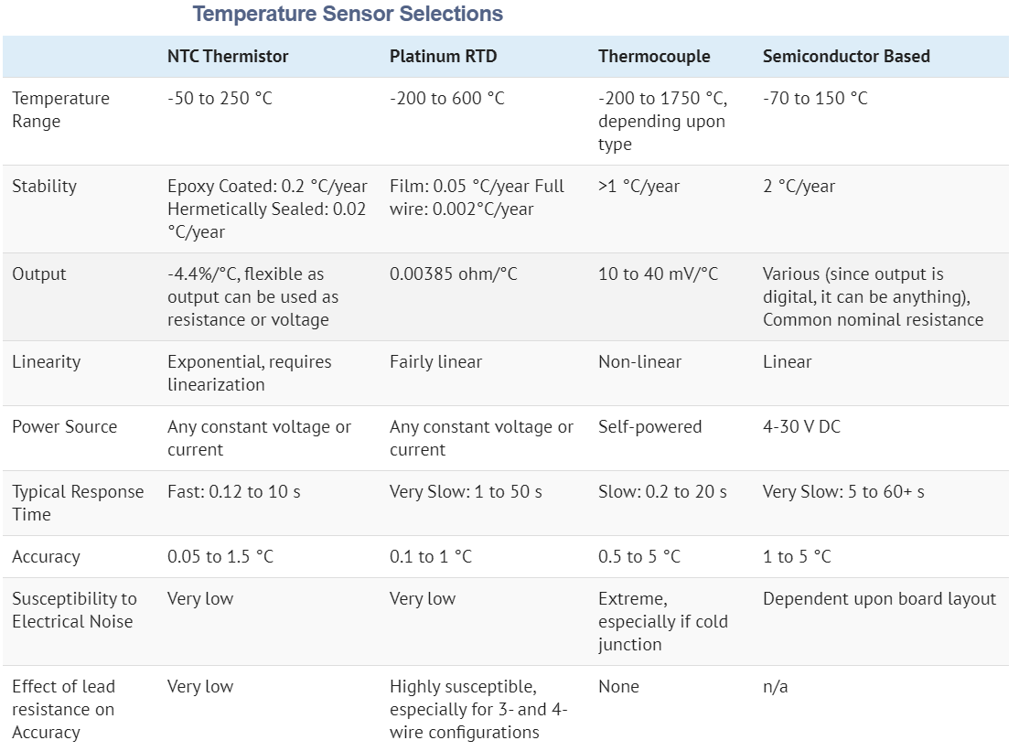

Figure 1: <https://www.ametherm.com/blog/thermistors/select-optimal-temperature-sensor>

LM75